**North Canterbury Price Comparison**

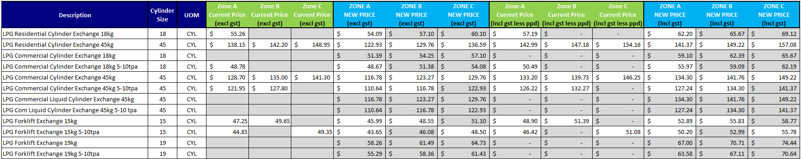

* The table above shows you the current customer price excluding GST, also including GST and less their prompt payment discount for comparison. If no rate has been supplied, then we did not have a customer on the current tariff or zone.
* The table below shows the new rental fee pricing excluding and including GST. All current rental fees are one price.
  + $41.74 excluding GST
  + $48.00 including GST

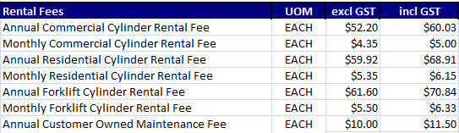

**Price Change FAQs**

* Why is Rockgas changing their pricing?

Rockgas continues to experience increases in the cost of supplying LPG to our customers.

This is due to several factors including:

• Increased energy prices, including LPG, largely due to the conflict in Ukraine.

• Higher transportation costs to deliver LPG to homes and businesses.

• Increasing operational costs, due to high inflation – with annual inflation at its highest level in three decades.

While we work hard to minimise the impact of these costs on our customers, unfortunately we need to adjust our LPG prices for North Canterbury customers, effective the 11th of December 2023.

While adjusting prices is never easy, please be assured that we will continue to deliver the best possible value and service to you.

* Will the carbon price continue to increase, and will this mean the LPG price will keep increasing?

Over the past 2 years there has been a number of policy changes by Government, that have led to the increase of the price of carbon units under the New Zealand Emissions Trading Scheme.

It is likely that we will see a continual increase in the price of carbon units in the near term, however, it is difficult to predict with any certainty the pace of any future price increases.

The New Zealand Emissions Trading Scheme and therefore the price of carbon is a key tool for the New Zealand Government to achieve its long-term commitment to reduce our greenhouse gas emissions towards meeting our domestic and international climate change targets, including the 2050 target set by the Climate Change Response Act 2002.

Check out gasischanging.co.nz and learn how Firstgas Group is working towards supplying our Rockgas customers with carbon efficient fuels in the future.

* What is the exact date my new pricing will begin?

The LPG price change will be effective from 11 December 2023.

* Can I contact or submit a complaint to the UDL about this Price change?

You can contact the UDL about the price change however, the UDL will not look into any complaint until your provider (Rockgas) has been given the opportunity to resolve the complaint with you first. Generally, Rockgas has 20 working days to resolve the complaint with you. Rockgas has a general complaints process if you would like to submit feedback. Please email customercomplaints@rockgas.co.nz.

Call: 0800 22 33 40

Email: info@utilitiesdisputes.co.nz

Web: www.utilitiesdisputes.co.nz

Mail: PO Box 5875, Wellington 6140

Freepost 192682

* Does Rockgas offer payment plans?

Unfortunately, we don’t currently, but if you are experiencing real hardship, we can arrange for someone from our finance team to make contact and provide options for assistance.

* What ways can I pay my invoice?

You can pay in Branch, Via Internet banking, Direct Debit and you can pay over the phone using your Credit Card.

* Why is my cylinder 45kg rental price increasing?

The cylinder rental fee has not changed for many years, as we have tried to keep costs to our customers down, while the cost of cylinders has continued to increase. This increase reflects the increased cost to supply cylinders to our customers.

* Why is my cylinder 15kg rental price increasing?

The cylinder rental fee has not changed for many years, as we have tried to keep costs to our customers down. Forklift maintenance fees have increased considerably, and the cost of forklift cylinders is 4 times more expensive to purchase. This increase reflects the increased cost to supply cylinders to our customers.

* I haven’t been charged rental fees in the past, why do I have to pay this now?

If you have not been charged rental fees in the past, this was in error, or it was a special limited time offer that has since ended. All customers using Rockgas cylinders should be charged a monthly or annual cylinder rental.

* Why am I charged a Customer Owned Cylinder Annual Maintenance Fee?

Your cylinder is added to the Rockgas pool of cylinders and maintained by Rockgas on your behalf. We ensure the cylinder meets current NZ/AUS gas regulations and is tested and maintained in accordance with these standards. The fee assists in covering these costs.

Note: If the customer leaves Rockgas, cylinders will be returned from the pool with current certification.

* When will my rental fee be charged?

Your rental fee will be charged monthly or annual on the month specified in your price change letter. NB: if they do not have it look at the month shown on their gas sales order record.

* What happens if I leave within the next year, do I get a rental refund?

If you move out of your location, we will provide a credit for the days or months you have overpaid for your rental. For example – You paid for 1 year and moved out after 3 months, a rental credit for 9 months would be applied to your final account.

* Why am I not getting my prompt payment discount?

Your invoice will no longer show a prompt payment discount. Our new customer management system does not support prompt payment discounts; therefore, we will be invoicing you on our best LPG rate tailored to your LPG supply and region.