**System Change FAQs**

North Canterbury

* Why is Rockgas changing its systems?

Our aging systems no longer provide the tools to support the excellent customer service experience Rockgas strives to provide its customers. In moving to a new system our aim is to modernise, simplify and provide tools that will improve our service to our customers.

Rockgas moved some of its customers to the new platform in June this year and now we our moving all Rockgas North Canterbury customers in December.

* Some of the benefits of moving to our new system include:

Improved Efficiency: Allows Rockgas to automate many of its manual processes that will improve efficiency and reduce errors, enabling us to deliver faster and more accurate services to our customers.

Better Data Management: Improve data management and help Rockgas to identify trends and improve its services based on customer needs.

Future Proofing: Rockgas will be better equipped to adapt to new technology and our customer’s demands in the future.

Overall, the move to a new system is a positive step for Rockgas and our customers. The improved tools, efficiency, data management, and future-proofing capabilities of our new system will allow Rockgas to provide improved customer service.

* Why is Rockgas changing my invoice due date (payment terms)?

Overall, the payment term is aimed at providing customers with greater flexibility and peace of mind when it comes to managing their payments. From the 11th of December any invoice will be due 20 days after the invoice date.

* As a Direct Debit customer will there be change to the payment date of the 5th of the month?

Instead of paying on the 5th of the following month, customers will be direct debited 20 days from the invoice date. The due date will be prominently displayed on customer invoices for convenience.

* Why is my account number changing?

When we move all Rockgas North Canterbury customers to the new system, the system will assign a new Account number. We are unable to keep the existing account number due to the current number format and sequence used.

* What is the location ID, and why is it changing?

At Rockgas, we assign a location ID to every customer address in order to more easily identify and track delivery locations. While you will be used to seeing a customer code on your invoice, we are transitioning to a new location ID system that will provide clearer identification for our customers. This new system will allow customers to identify more easily which of their sites we are referring to and can improve delivery accuracy and streamline our operations.

For most customers, their location ID will be simply known as “Main”, as they will only have one delivery location. However, for customers with multiple supply addresses, this system will provide an additional way to identify each delivery location. Some examples of possible secondary location IDs include “Flat”, “Barn”, “Granny Flat”, “Office”, or “Shed”. Overall, this new system is aimed at improving our service to customers by providing clearer and more accurate location identification.

* Why is my invoice changing?

With the change in System, you will receive a new modernised invoice. The improved format should make the invoice clearer to read for customers. Your new Account number and Location ID will be shown on the top right of your invoice. The new format is shown below.

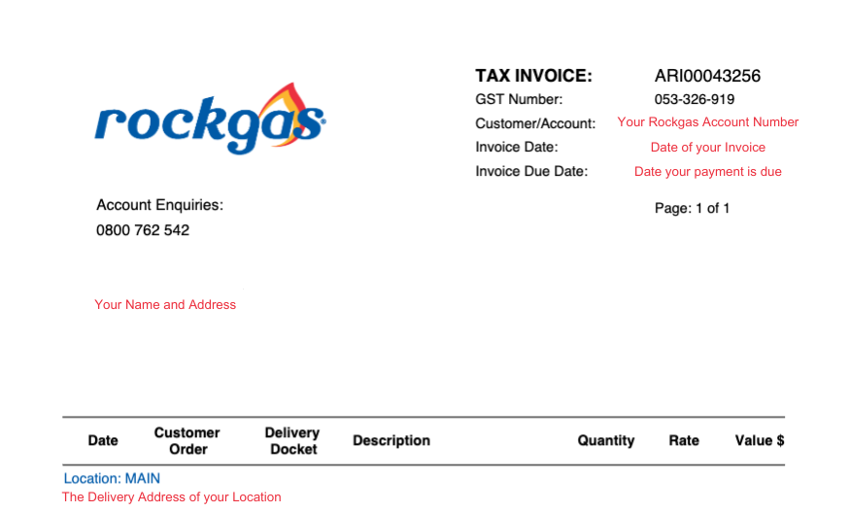

* Why am I being charged per cylinder instead of per KG of LPG?

The new customer management system has a new modernized invoice. The new invoice is setup to charge customers per cylinder instead of per kg, because this is how we delivery to customers. When we deliver to a household or business in North Canterbury, we deliver a cylinder of LPG.

Invoicing customers per cylinder makes it easier for the customers to match the invoice to their delivery and any delivery notifications. The format change does not change the price the customer pays, it simply invoices the total value instead of multiplying the Kg price by the cylinder size on the invoice.

* Why are you taking away the prompt payment discount?

Your invoice will no longer show a prompt payment discount, as our new customer management system does not support prompt payment discounts. Going forward, we will be invoicing you on our best LPG rate tailored to your LPG supply and region.

* When will I receive delivery notifications?

Customers who choose to receive delivery notifications will be alerted both the night before and the morning of their delivery, as well as upon completion of the delivery. In the past you may have received email delivery notifications, if you would like to receive text notifications, please notify us via this link. <https://rockgas.co.nz/rockgas-enhance/>

* Will there be changes to my delivery days?

Our new system enables us to efficiently deliver gas to more customers and minimise overall wait times. Our delivery days will remain the same for all areas. If there is any change to these days in the future, we will notify customers.

* Will I still be able to schedule a delivery day?

Thanks to our improved customer delivery notification system, we will no longer require customers to book a specific delivery day. Instead, we will provide advance notice of the scheduled delivery the night before and morning of the delivery, allowing customers to put dogs away and open gates for example, ensuring our driver has safe access to make their LPG delivery. If for any reason a customer needs to book a specific day, our team can accommodate this with reasonable notice, subject to availability.

* If Rockgas is unable to complete my delivery, will I be notified?

If, for any reason, Rockgas is unable to complete your delivery, customers who are set up to receive delivery notifications will be notified shortly thereafter and provided with an explanation for the delay.

* Why is the Bank Account for payment Changing

In July 2022 Rockgas purchased the North Canterbury Franchise. The bank account was with Westpac, and we will be transitioning to the Rockgas BNZ bank account. This will ensure we can allocate all customer payments easily and efficiently.

From 11December 2023, you will need to make payments to our BNZ bank account using your new Account number and Name as your reference.

To setup the bank payee use the details below:

|  |  |  |  |
| --- | --- | --- | --- |
| **Bank Account Number** | | 02-0544-0241419-00 | |
| **Bank Payee Name** | | Rockgas Limited | |
| **Particulars** | **Code** | | **Reference** |
| Account Name | Location ID (Optional) | | Account Number |

* Do I need to make a change to my Direct Debit?

For Customers paying through direct debit, you do not need to do anything. We will make all necessary changes to ensure your direct debit continues as normal.

* What do I do if I pay into the wrong account?

In the event you make a payment to the old bank account, simply email or call us with the following details, and we will locate your payment and apply this to your account.

* Bank account Name
* Bank account number (The payment was made from)
* Bank account number (The payment was made to)
* Amount paid
* Date of payment
* Payment reference
* What change do I need to make to my bank payee?

From 11December 2023, you will need to setup a new bank payee using the following information.

|  |  |  |  |
| --- | --- | --- | --- |
| **Bank Account Number** | | 02-0544-0241419-00 | |
| **Bank Payee Name** | | Rockgas Limited | |
| **Particulars** | **Code** | | **Reference** |
| Account Name | Location ID (Optional) | | Account Number |

If you already have Rockgas North Canterbury setup as a payee, from 11 December 2023 you will need to search and setup Rockgas Limited as your new payee. Rockgas North Canterbury will be removed as a valid payee with all banks.

* What changes have been made to the Rockgas Terms and Conditions?

Most of the changes to our terms and conditions have been implemented to support the updates outlined above. We highly recommend that all Rockgas customers take the time to review and become familiar with the Sale and Supply of Rockgas LPG terms and conditions on our website. This will enable customers to have a better understanding of the changes and how they may impact services, as well as ensure that customers are up to date with the Rockgas policies and procedures.

* How to make an Order?

There are a number of ways you can place an order with us, these are detailed as follows,

* Website – Visit our website using the link (INSERT) and place an order online 24/7.
* Rockgas App – You can download the Rockgas App and place an order through the app. To download the app go to the Play store or Apple store.
* Email – You can email us to request an order on [LPGenquiries@rockgas.co.nz](mailto:LPGenquiries@rockgas.co.nz)
* Call us – Call 0800 762 542 and place an order with one of our friendly customer service team between 7am - 7pm Monday to Friday, or 8am – 5pm on Saturdays.
* How to update my Rockgas App with my new Account Number?

If you already use the Rockgas App for payments, you will need to update your Account number. Follow this link to see how to make these changes (INSERT LINK)

If you have more than one location, the Rockgas app will not be able to be used for orders. Please order online through our website. (INSERT LINK)